Project Meeting Minutes: April 6, 2026

1. Attendance
- Dylan Bajeux
- Aurore Galand
- Bertrand Martin
- Kévin Prist
- Simon Tempels

2. Discussion

A. Platform (Website)
- Main Landing Page: General information and login possibility.
- Login gives access to another page with more features:
  - Join a game button
  - Profile
  - ± chat
  - ± notification
- Profile page:
  - Starter → possibility to choose the starter used for the game [selection from a fixed set ?]
  - Statistics about the game (fight won/lost, damaged dealt, mean place, …)
Clicking on the play button leads to the participation of a game by creating a new lobby or joining an already existing one.

B. Game Loop
The game progression follows this structure:
Lobby → Exploration → PvP → [[[Exploration →] PvP →]...] Lobby
PvP = Player vs player.
Exploration phase is always followed by at least one PvP phase. There could be several PvP phases in a row.
All matches are already decided following a tournament pattern such as given in Fig. 1.
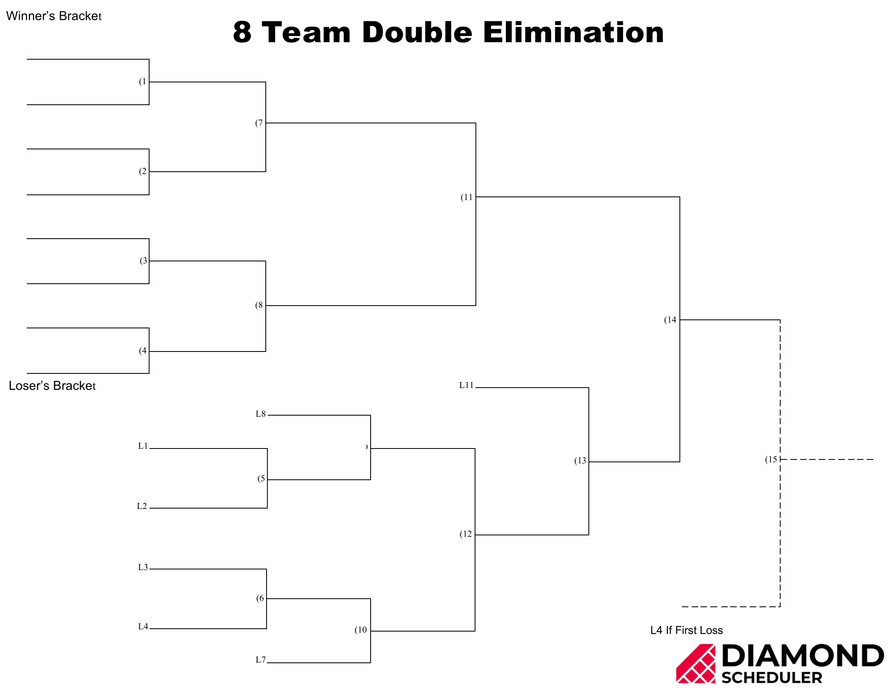Figure 1
This information will be accessible to the player in-game.
- in between PvP rounds?
- Via menu ?

The Lobby

Lobby filling
- Lobby is progressively filled with players until the target number of player is reached. The target is fixed. 8 players was suggested for the target.
- If the target is not reached within a fixed amount of time, AI players will fill in for missing players.

Map Selection
- Selection is done by voting between a fixed number of maps [with the suggestion that not all maps are available in the beginning].
- AI player can also vote [randomly ?]

Game starts after countdown or after every vote has been confirmed.

Exploration Phase
The player will build/improve his team for the following PvP phase, his next opponent already being known.
- Each player navigates their own private map instance (no direct player interaction).
- The starting point is the same for every player.
- Every player starts with one monster called starter
  - starters have all the same stats [or average stats] but are different by design
  - a player’s starter is defined in his profile page and cannot be change during a Game
- Objects are visually represented and can be picked.
- Monster capture method → TBD between two options:
  - walking on them, implies visual representation of the monster
    - moving herbs, shape in the water, ground mound, …
    - monster directly visible
    - Eventual movement pattern
  - Fighting system
    - Fight occurs within a range of fixed steps [example: between 5 to 15 steps] either in general or specific area like high herbs, water, cave, …
    - Enemy selection is influenced by parameters (area of the map, distance to starting point, …)
    - A “monsterball” has to be used to capture the monster
    - Success of capture is dependant on the monster’s remaining life
    - Monster has possibility to flee ?
- Captured monsters are automatically added until team is filled.
- If team is filled, new captured monster can only be added if another monster is released.
- Target number of monster in the team is 6.

- Healing ? [pending on Capture method]
  - Do monster have to heal after each fight ?
  - Where/How ?
- Object → consumables
  - Monster improvement (evolution, stats improvement, new fighting techniques)
  - Healing
  - Other
[if capture method doesn’t imply fights, suggestion that consumables can only be used in PvP phase]
- No XP system

After countdown starts PvP phase

PvP Phase

Battle
- 1 vs 1
- Turn by turn
- Winner = first to knock out the 3 monsters of his opponent
- Who starts:
  - random ?
  - chess system → in advance every player knows if he is playing first or not in the next macth
- 1 action per turn between 3 options:
  - Attack → choice between a set of techniques
  - Object → Use an object
  - Switch monsters → exchange active monster with another one
  - Forfeit → Not really an option but if player leave, he is forfeited for the rest of the game with eventual ban.
- Player has a limited time to choose an action→ TBD between:
  - fixed time for each turn
  - time decreased in the next turn if exceeded
- Random attack if time exceeded ?

During match, info of other players matches is displayed, allowing to glimpse informations of other players team.

End of PvP
- Results are made known [how ?] for everyone so that you know your next opponent.
- Next phase can be :
  - another PvP
  - an exploration phase
  - return to the lobby if all matches have been played.

Lobby (Conclusion)
- Display of final results
- Statistics [damage dealt, received, …]
- Displays of maps with path walked and available monsters [suggested]
- Chat between players
- Social option to add friends, censure/report people ?
The tournament follows a pre-defined bracket so players know their next opponent.
- Preparation: Selection of 3 monsters from the team and deciding their order.
- Battle Mechanics:
  - 1 vs 1 turn-based combat.
  - Actions: Attack, use Item, or Switch (Switching costs a full turn).
  - Turn Timer: Limited time per decision. If exceeded, a random attack is chosen.
- Visibility: Match info for other players is displayed, allowing teams to be scouted.

3. Next Meeting

April 21, 2026, 1:00 PM

Agenda:
- Unfinished points of last meeting → decision

- Technologies stack → discussion
  - languages
  - frameworks
  - libraries, …

- Software architecture strategy and objectives → discussion
  - Load Balancing (Needed ? How many user at the same time ?)
  - Maintainability and Scaling
  - Storage
  - Speed/Efficiency
  - …

- Task Allocation → discussion
  - Who is coding what ?
    - Frontend
    - Backend
    - Game Engine
    - Sockets
    - …
  - Preferences

- Dev environment tools → decision
  - Which tools ?
    - Vs code
    - nvim, plugins
    - Database GUI
    - …

To Do:
For everyone:
- Research next meeting’s topic (technologies and architecture strategies)
- Check preferences for specific parts of the project (what you want to work on)
- Chose the basic tools you need for coding (further tools can of course be added later)

